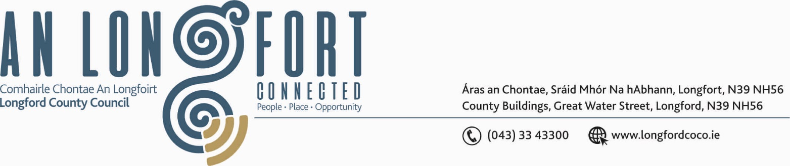
5u Mean Fomhair 2019.

Chuig: Gach Ball don Chomhairle.

A Chomhairleoir,

Iarrtar ort bheith i láthair ag Cruinniú Chomhairle Chontae Longfoirt a tionólfar i Seomra na Comhairle, Aras an Chontae, Longfoirt ar an Chéadaoin, 11u Mean Fomhair 2019 ag 3.00 p.m. chun gnó a dhéanamh d’réir an Chláir thíos.
You are requested to attend Meeting of Longford County Council to be held in the Council Chamber, Aras an Chontae, Great Water Street, Longford, on Wednesday, 11th September 2019 at
3.00 p.m to transact business, as set out on the Agenda hereunder.

Mise le meas,
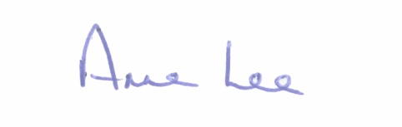

_______________
Anne Lee,
Meetings Administrator.

2.50 p.m. Longford County Childcare Committee will give a presentation regarding the new National Childcare Scheme.

C L A R

Prayer before Meeting.

- Confirmation of Minutes of the following meetings of Longford County Council –
- Meeting held on the 10th July 2019.
- Special Meeting held on the 31st July 2019
– enclosed.

- Matters arising from Minutes.

3. Declaration of Interest by Members.

4. To note Management Report - enclosed.

5. To note adopted Minutes of Corporate Policy Group Meeting held on
8th May 2019 – copy enclosed.

6. Community, Corporate and Enterprise.

- Strategic Policy Committee Scheme 2019 – 2024 - Updated draft enclosed.

- Corporate Plan Preparation – Updated Guidelines for Local Authorities in the preparation of their Corporate Plan 2019 to 2024 - Guidelines attached.

- Consideration of Draft Sports Bursary Scheme - enclosed.

- Consideration of recommendation from Corporate Policy Group regarding Receptions for the
following –
- Longford Slashers U14 Hurling Fèile na nGael winners
- Clonguish Òg U14 Boys Fèile Peile na nÒg winners
- Clonguish Òg U14 Girls Fèile Peile na nÒg winners

- Consideration of correspondence received from Disability Federation of Ireland regarding
“Make Way Day’ Campaign.

- Notice of Motion, submitted by Councillor Mark Casey.

“I propose that Longford County Council reverts back to Monthly Meetings, and if not, that all Councillors’ allowances should reflect the reduction in meetings, including the Cathaoirleach.”

7. Finance & Regeneration.
(a) To consider the Local Property Tax Variation in accordance with the provisions of Section 20 of the Finance (Local Property Tax) Act 2012.

(b) To fix dates for the following Meetings -
- Municipal District Meetings to consider draft Budgetary Plan for 2020.
- Longford County Council Finance Committee meeting to consider 2020 Budget.
- Longford County Council Statutory meeting to consider 2020 Budget.

- To approve the raising of a loan of €2,535,517 from the Housing Finance Agency plc to
support the Rebuilding Ireland Home Loans (RIHL) Programme.

(d) Issue and acknowledgement of Acceptable Usage Policy Document- enclosed.

(e) Notices of Motions submitted by Councillors, as listed hereunder -

Councillor Joe Flaherty

“Call on the regeneration team to explore with Failte Ireland and the Minister for Transport & Sport, the possible development of a National Transport Museum in Longford town as part of the Camlin Quarter plans.”

8. Strategic Infrastructure and Climate Change.

- To note Planning Applications received since last meeting of the Council.

- Consideration and adoption of Draft Climate Change Adaptation Strategy – enclosed.

- Consideration and adoption of Part 8 Report (Planning and Development Act 2000 (as amended) and Planning and Development Regulations 2001) (as amended) in respect of construction of 2km Path linking Drumlish with Mondaduff Sports Grounds at Barragh More, Derawley and Monaduff, Drumlish, Co. Longford - details attached.

- Consideration and adoption of Part 8 Report (Planning and Development Act 2000 (as amended) and Planning and Development Regulations 2001) (as amended) in respect of construction of Walkway at Royal Canal, Longford Town – details attached.

- Consideration and adoption of Part 8 Report (Planning and Development Act 2000 (as amended) and Planning and Development Regulations 2001) (as amended) in respect of construction of Trackway at Knappogue Bog - details attached.

- Consideration and adoption of Part 8 Report (Planning and Development Act 2000 (as amended) and Planning and Development Regulations 2001) (as amended) in respect of construction of 3 no. 2 Bed single storey dwellings at Cranleymore, Abbeylara - details attached.

- Consideration and adoption of Part 8 Report (Planning and Development Act 2000 (as amended) and Planning and Development Regulations 2001) (as amended) in respect of construction of Amenity Trackway through part of Edera Bog, Longford – details attached.

- Consideration and adoption of Material Contravention of Longford County Development Plan 2015 – 2021 in accordance with Section 34(6) of the Planning and Development Act 2000 (as amended) for the proposed construction of a residential development of
24 no. dwelling houses at Rathcronan, Granard, Co. Longford - details attached.

- Notices of Motions submitted by Councillors, as listed hereunder –

Councillors Paul Ross and P.J. Reilly.

“That Longford County Council reinstates the position of Estate Manager in the Housing Section of Longford County Council to help work with and maintain our Council Housing Estates and that the Better Estates Awards be held in 2019.”

Councillor Gerry Warnock.

“I am calling on the Minister for Housing, Planning & Local Government,
Eoghan Murphy TD, to make provision in the upcoming budget for an Affordable Housing solution for rural counties such as Longford, whose circumstances in this regard are not deemed to be compatible with current guidelines.”

9. General

- Correspondence - copies enclosed.

- Letter dated 12th July 2019 received from the Office of the Minister of State, Department of Agriculture, Food and the Marine regarding the RTE investigation into the greyhound sector.
- Letter dated 19th July 2019 received from the Chief Executive Officer, Irish Greyhound Board regarding the RTE investigation into the greyhound sector.
- Letter dated 12th August 2019 received from The Department of Employment Affairs and Social Protection regarding Tools and Material Budgets for CE Schemes.

- Notices of Motions, submitted by Councillors, as listed hereunder –

Councillors Paul Ross and Micheal Carrigy.

“That Longford County Council calls on the HSE/ Department of Health to grant access to the drug Nusinersen ( Spinraza) for all adults, following on from the decision to grant access to the drug for all those under 18.”

Councillors Paul Ross, P.J. Reilly and Paraic Brady.

“That a dedicated two bed palliative care unit with ancillary accommodation be included in the design plans to redevelop St. Joseph’s Campus in Longford and that Longford Hospice Homecare be consulted on these design plans.”

Councillor Joe Flaherty.

“That this Local Authority and our sister bodies, call on The Taoiseach and Minister for Defence to finally issue the 33 Distinguished Service Medals to the heroes of the Jadotville Siege.”

Councillor Gerry Warnock.

“I am calling on Longford County Council to write to An Taoiseach, Leo Varadkar TD, in his capacity as the Minister for Defence, requesting that he issue a directive to the Army Authorities to issue the thirty-three medals (previously recommended by Comdt Quinlan) to the surviving Veterans of Jadotville and to the families of the those deceased.”

Councillor Gerard Farrell.
I call on Minister Creed to initiate an enquiry into the meat industry to get some transparency to see if there can be a fair price paid to farmers.”

10. Training -
Consideration of Report from Corporate Policy Group.

11. Votes of sympathy.



